Task 3

List down the methods of linked lists..

LinkedList methods: add(), addFirst(), addLast(), remove(), removeFirst(), removeLast(), get(), getFirst(), getLast(), contains(), size(), clear().

Task4::
Traversing: Visiting each element in the data structure one by one.
Insertion: Adding a new element to the data structure.
Deletion: Removing an existing element from the data structure.
Searching: Finding the location of a specific element.
Sorting: Arranging elements in a specific order (e.g., ascending or descending).

Task5::
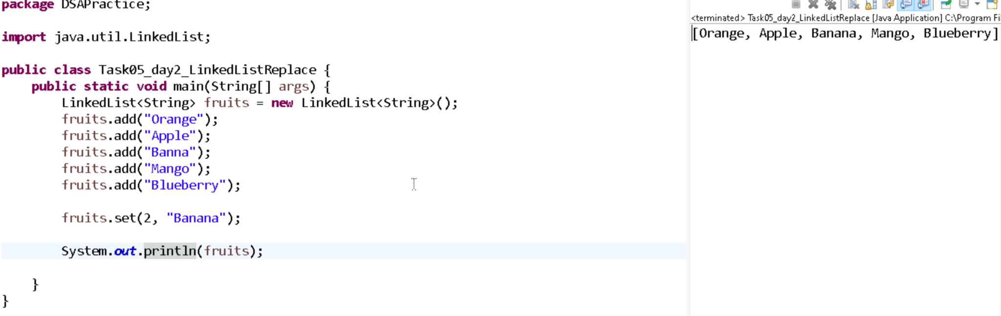

Task6::
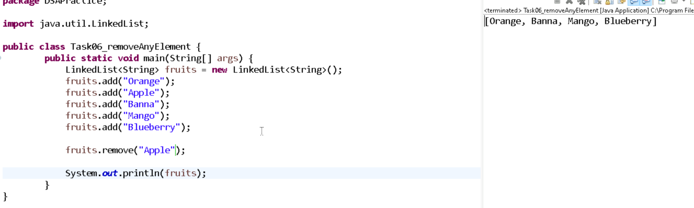

Task7::
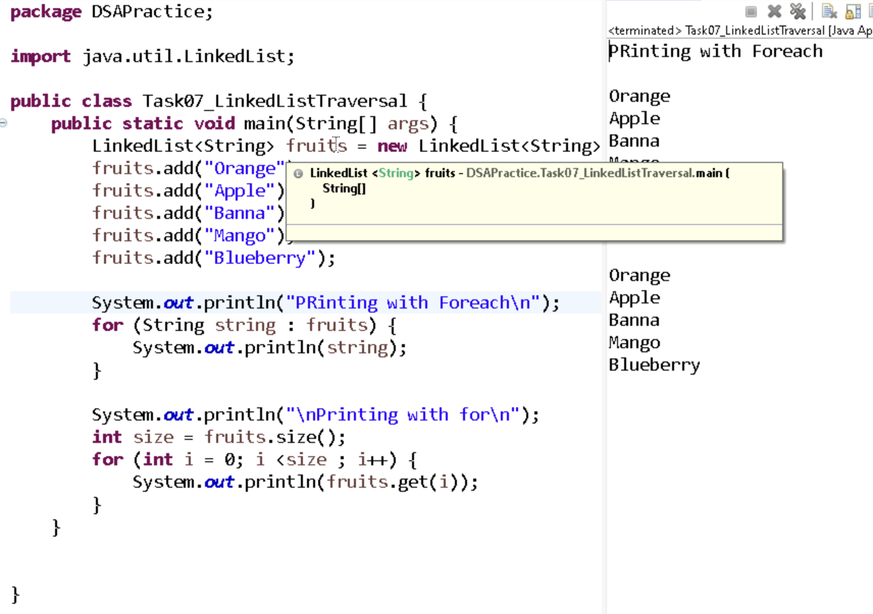
Task8::
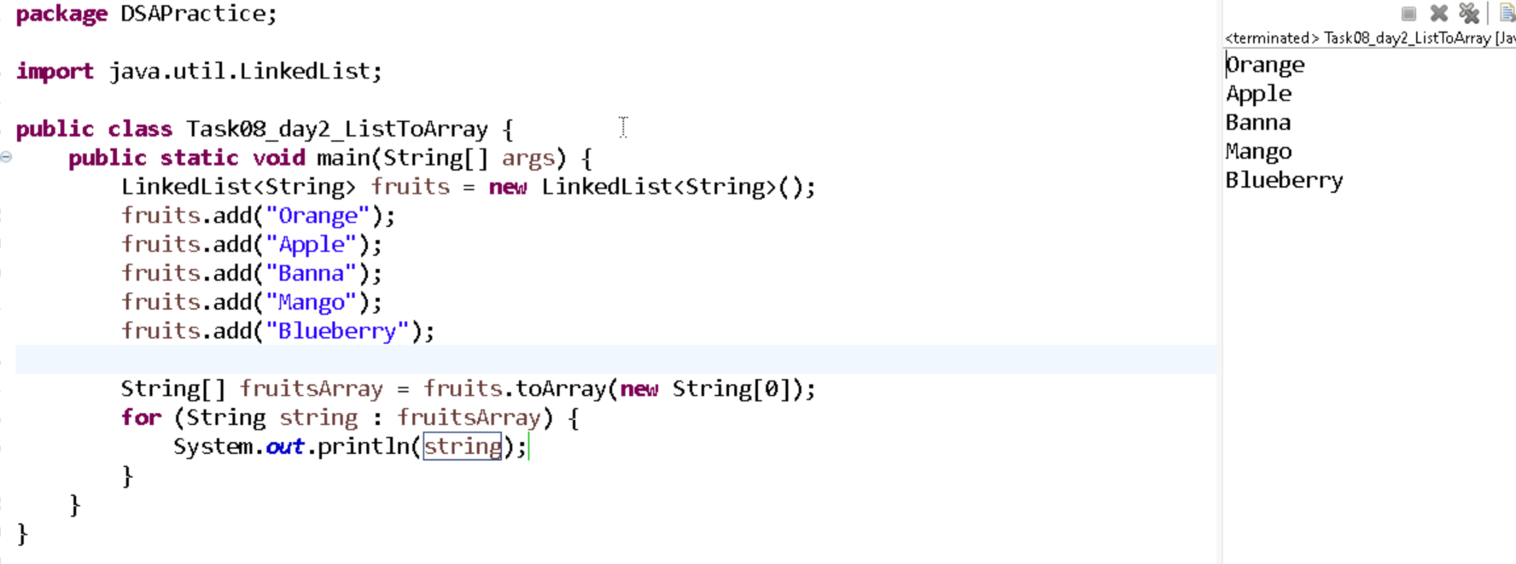

Task9 ::
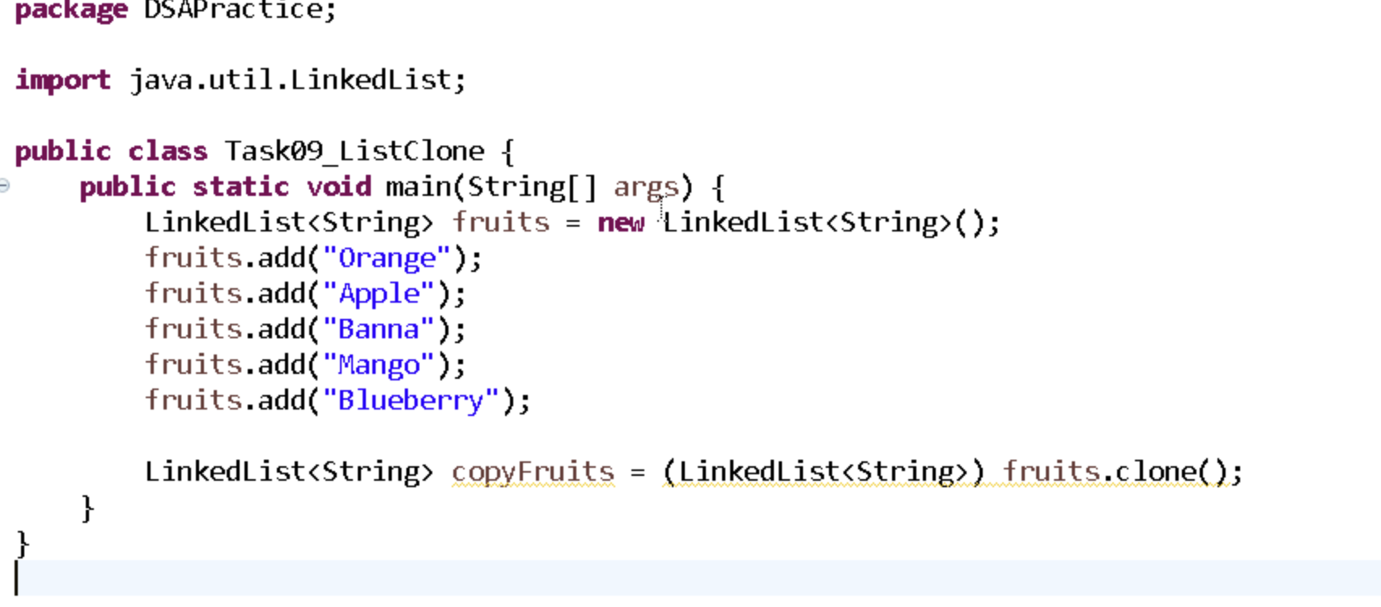
Task10::
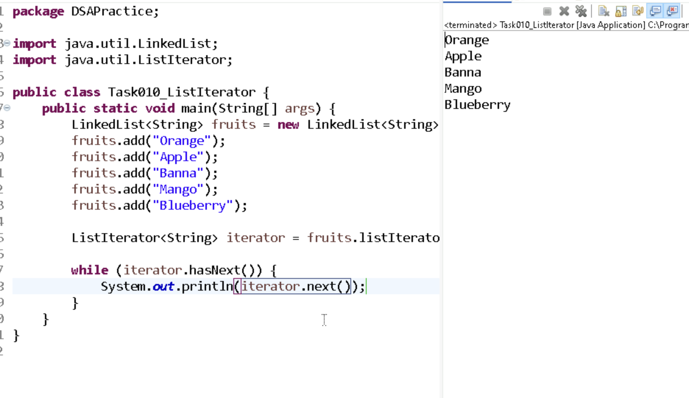

Task11::
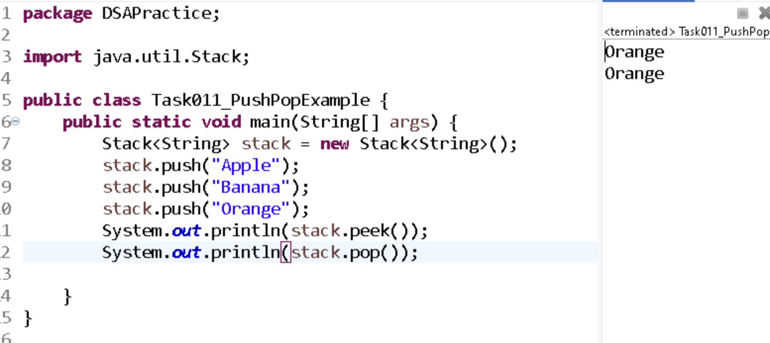

Task12::

Feature | ListIterator | Spliterator
Direction | Forward & Backward | Forward only
Can modify elements? | ✅ Yes (add, remove, set) | ❌ No direct modification
Supports parallelism | ❌ No | ✅ Yes (trySplit())
Works with Streams | ❌ Rarely used | ✅ Commonly used
Collection Types | Only for List | For all Collections
Use Case | Manual, flexible traversal | Fast, scalable traversal (esp. in Streams)

Task13::
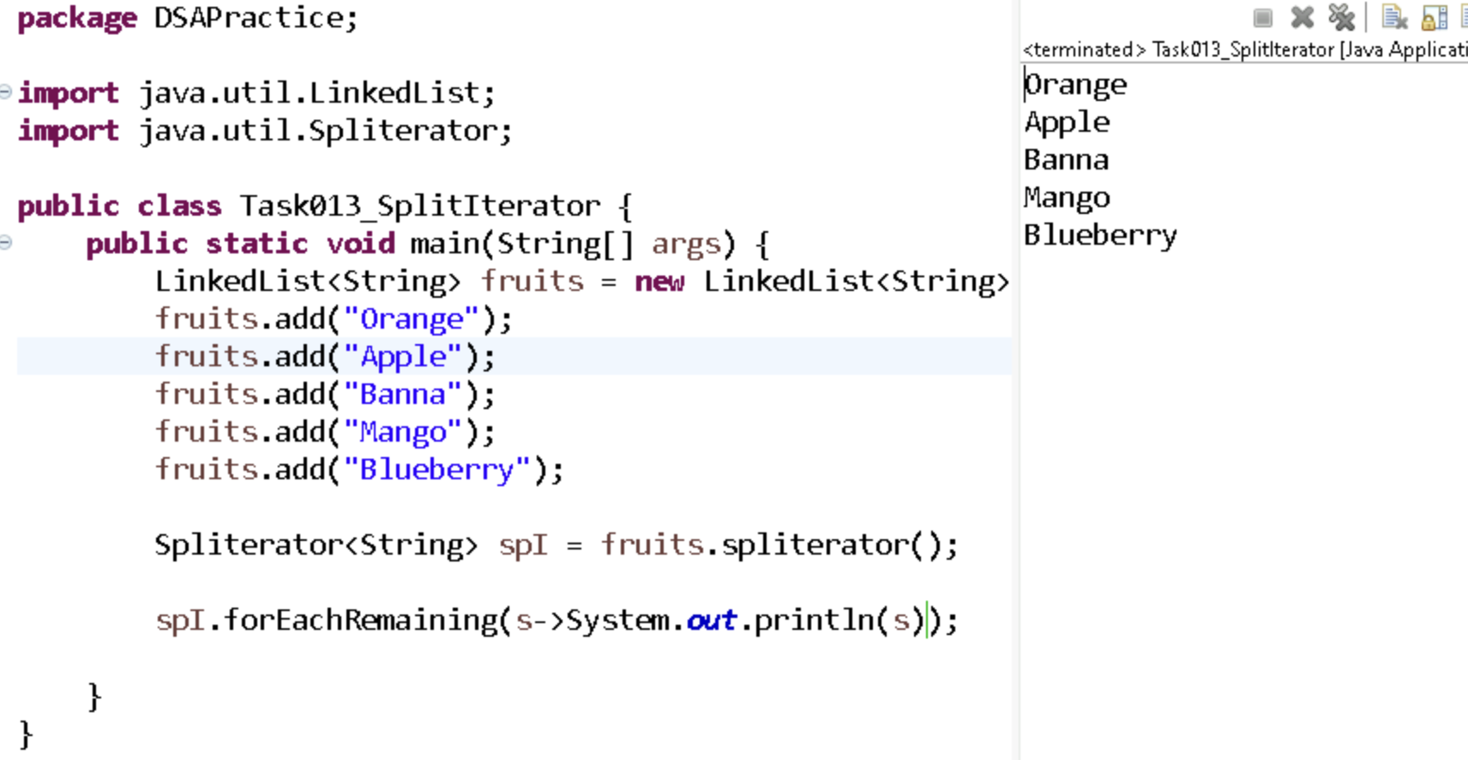

Task13::
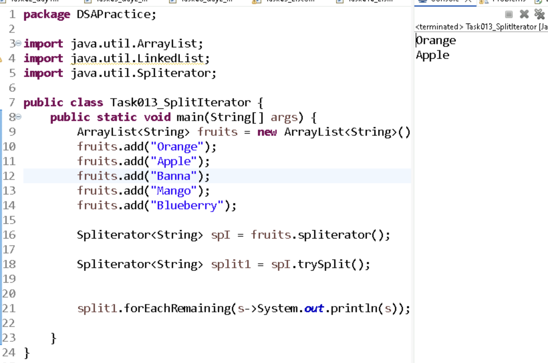

Task15::
A pointer is a variable that stores the memory address of another variable. It allows indirect access to the value stored at that address, commonly used in languages like C and C++.
Task16::

Symbol | Meaning | Example
* | Dereference operator – accesses the value at a pointer address | *ptr gives the value stored at ptr
& | Address-of operator – gets the memory address of a variable | &x gives the address of variable x

Task17::
#include <stdio.h>

int main() {
int x = 10;
int *ptr; // Pointer declaration

ptr = &x; // Store address of x in ptr

printf("Value of x: %d\n", x);
printf("Address of x: %p\n", &x);
printf("Value stored in ptr (address of x): %p\n", ptr);
printf("Value pointed to by ptr: %d\n", *ptr); // Dereferencing

return 0;
}
